**8-BIT SUBTRACTION**

**EXP NO: 2**

**AIM:** To write an assembly language program to implement 8-bit subtraction using 8085 processor.

**ALGORITHM:**

1. Start the program by loading the first data into the accumulator.
2. Move the data to a register.
3. Get the second data and load it into the accumulator.
4. Subtract the two register contents.
5. Check for borrow.
6. Store the difference and borrow in the memory location.
7. Halt.

**PROGRAM:**

LDA 8000

MOV B, A

LDA 8001

SUB B

STA 8002

RST 1

**INPUT:**

; Program: 8-bit subtraction in 8086

; Emulator: emu8086, MASM, TASM

data segment

num1 db 45h ; first number (69 decimal)

num2 db 25h ; second number (37 decimal)

diff db ? ; result

data ends

code segment

assume cs:code, ds:data

start:

mov ax, data

mov ds, ax

; Perform subtraction

mov al, num1 ; AL = num1

sub al, num2 ; AL = AL - num2

mov diff, al ; store result

; Convert to decimal for printing

mov ah, 0

mov bl, 10

div bl ; AX ÷ 10 → AL=quotient (tens), AH=remainder (ones)

; Print tens digit

add al, 30h ; convert to ASCII

mov dl, al

mov ah, 02h

int 21h

; Print ones digit

add ah, 30h ; convert to ASCII

mov dl, ah

mov ah, 02h

int 21h

; Exit

mov ah, 4Ch

int 21h

code ends

end start

**OUTPUT:**

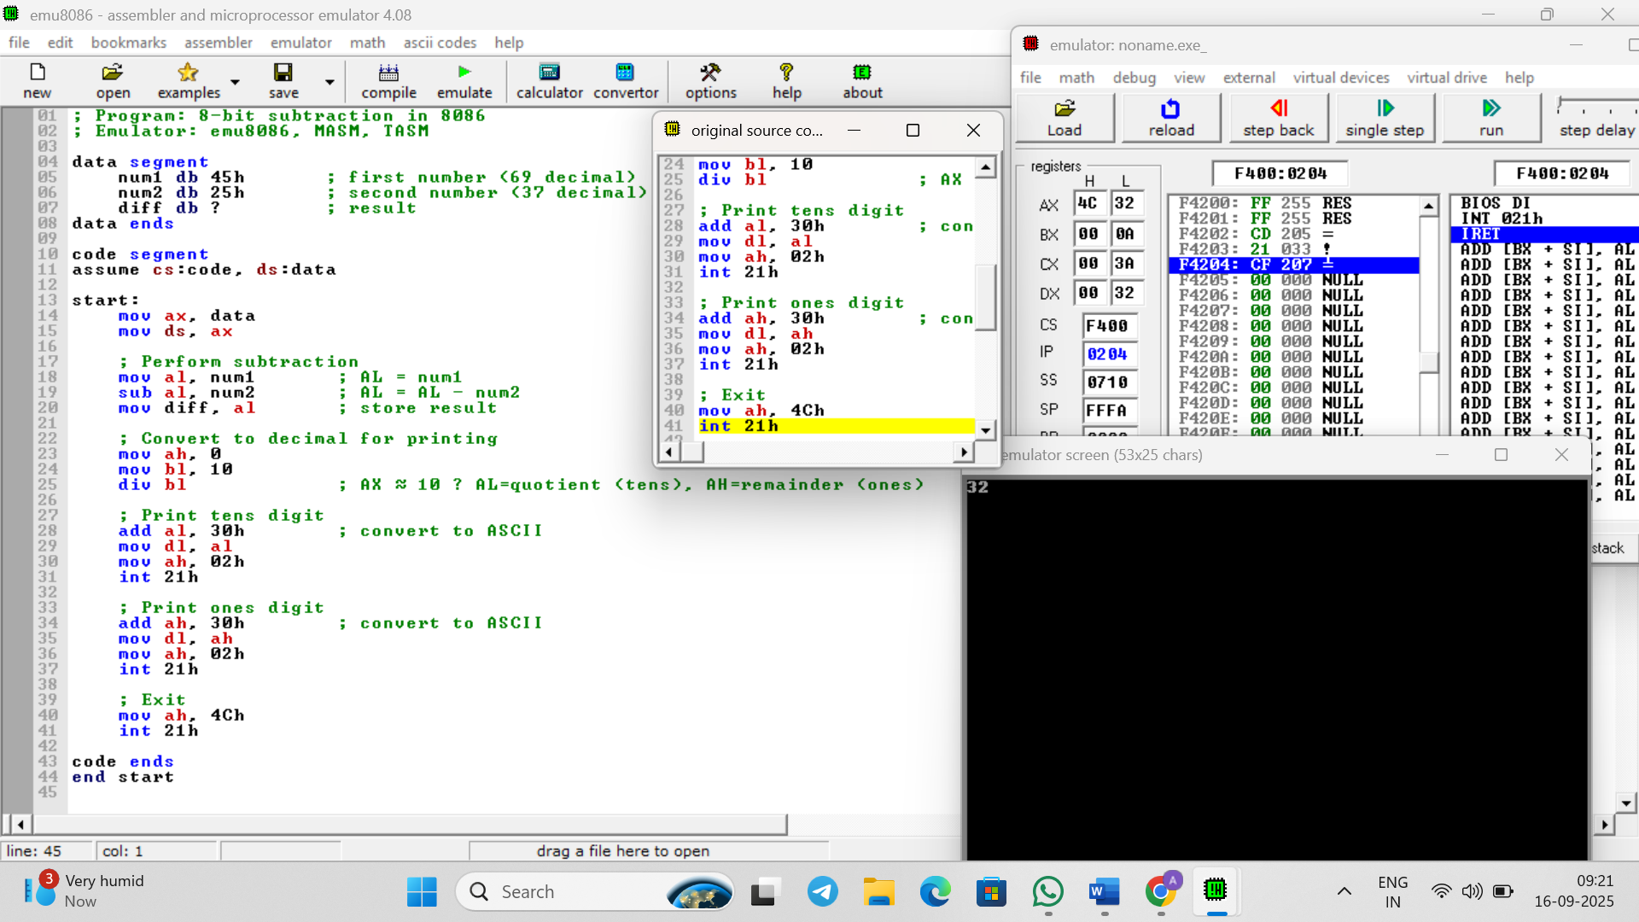

**RESULT:** Thus the program was executed successfully using 8085 processor simulator.